|  |  |
| --- | --- |
|  | **DEPARTMENT OF COMPUTER ENGINEERING** |



Semest

er



S.E. Semester III



–



Computer Engineering



Subj



Computer Graphics



Subject Professor In



-



char



Prof. Sachin Deshpande



Assisting

Teachers



Prof. Sachin Deshpande



|  |  |
| --- | --- |
| Student Name | Trisha Shah |
| Roll Number | 20102A0004 |

**EXPERIMENT DETAILS:**

|  |  |
| --- | --- |
| Title | Write a program to implement Bezier Curve Generation. |
| Tools/Language Used | Dev C++ |

**Bezier Curves**

Bezier curve is discovered by the French engineer Pierre Bézier. These curves can be generated under the control of other points. Approximate tangents by using control points are used to generate curve. The Bezier curve can be represented mathematically as −

∑k=0nPiBni(t)

Where pi is the set of points and Bni(t) represents the Bernstein polynomials which are given by −

Bni(t)=(ni)(1−t)n−iti

Where n is the polynomial degree, i is the index, and t is the variable.

The simplest Bézier curve is the straight line from the point P0 to P1. A quadratic Bezier curve is determined by three control points. A cubic Bezier curve is determined by four control points.

**Program :**

#include<graphics.h>

#include<math.h>

#include<conio.h>

#include<stdio.h>

void main()

{

int x[4],y[4],i;

double put_x,put_y,t;

int gr=DETECT,gm;

initgraph(&gr,&gm,"C:\\TURBOC3\\BGI");

printf("\n***** Bezier Curve *****");

for(i=0;i<4;i++)

{

printf("\n Please enter x and y coordinates ");

scanf("%d%d",&x[i],&y[i]);

putpixel(x[i],y[i],3);

}

for(t=0.0;t<=1.0;t=t+0.001)

{

put_x=pow(1-t,3)*x[0]+3*t*pow(1-t,2)*x[1]+3*t*t*(1-

t)*x[2]+pow(t,3)*x[3];

put_y=pow(1-t,3)*y[0]+3*t*pow(1-t,2)*y[1]+3*t*t*(1-

t)*y[2]+pow(t,3)*y[3];

putpixel(put_x,put_y,WHITE);

}

getch();

closegraph();

}

**Output:**

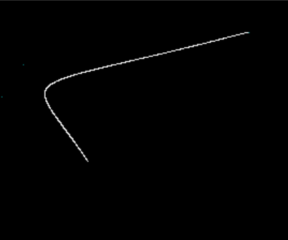

**Properties of Bezier Curves**

**Bezier curves have the following properties −**

* They generally follow the shape of the control polygon, which consists of the segments joining the control points.
* They always pass through the first and last control points.
* They are contained in the convex hull of their defining control points.
* The degree of the polynomial defining the curve segment is one less that the number of defining polygon point. Therefore, for 4 control points, the degree of the polynomial is 3, i.e. cubic polynomial.
* A Bezier curve generally follows the shape of the defining polygon.
* The direction of the tangent vector at the end points is same as that of the vector determined by first and last segments.
* The convex hull property for a Bezier curve ensures that the polynomial smoothly follows the control points.
* No straight line intersects a Bezier curve more times than it intersects its control polygon.

**Disadvantage**

• The degree of the Bezier curve depends on the number of control points.

•The Bezier curve lacks local control. Changing the position of one control point affects the entire curve.